Declaration of Conformity (DoC)

We, HONG KONG LELEGAO TECHNOLOGY CO., LIMITED
19H MAXGRAND PLAZA NO 3 TAI YAU STREET SAN PO KONG KL
Declare that the DoC is issued under our sole responsibility and belongs to the following product(s):

Product Type: | Portable LCD Display
Trademark： | Blackview
Model Number(s): | DCM5

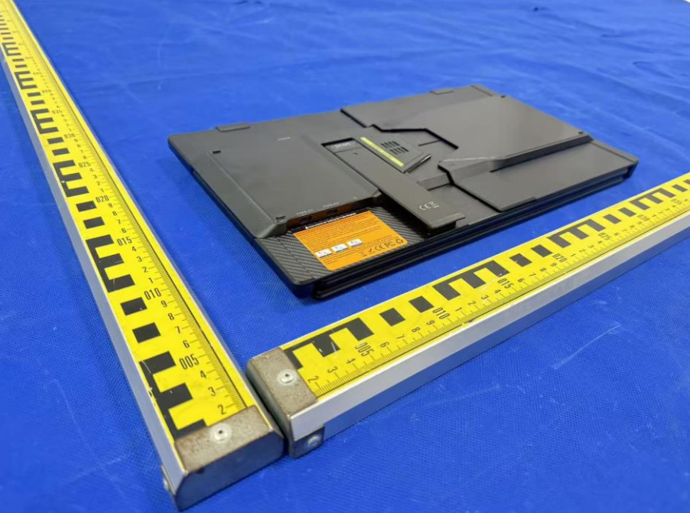

The object of the declaration described above is in conformity with the essential requirements of the relevant Union harmonization legislation: LVD Directive (2014/35/EU),EMC Directive (2014/30/EU)
The following harmonized standards and technical specifications have been applied:

SAFETY :

EN IEC 62368-1:2020+A11:2020

EMC :

EN 55032:2015+A1:2020
EN 55035:2017+A11:2020

The submitted samples of the above equipment has been tested and found to comply with the following European
Directives: RoHS Directive 2011/65/EU & (EU) 2015/863
ROHS:
IEC62321-1:2013, IEC62321-3-1:2013, IEC62321-4:2013
IEC62321-5:2013, IEC 62321:6-2015, IEC 62321-7-1:2015
IEC 62321-7-2:2017, IEC 62321-8:2017

Technical file held by: Shenzhen DOKE Electronic Co.,Ltd
Address: 801, Building3, 7th Industrial Zone, Yulv Community, Yutang Road, Guangming District, Shenzhen, China

Signed for and on behalf of: Shenzhen Doke Electronic Co., LTD

Name and Title: | Xie ce / Manager
Address: | 801, Building3, 7th Industrial Zone, Yulv Community, Yutang Road, Guangming District, Shenzhen, China

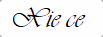

Signature of Authorized Person
2026-4-27

